REPORT TITLE:
Education, Income, and Employment Trends Across Indian States (2001-2011): A Data Analytics Study for NayePankh Foundation

1. INTRODUCTION
NayePankh Foundation works towards education and youth empowerment across India. This study analyses state-wise government data on literacy, income, unemployment, and poverty from 2001 to 2011 to identify patterns that can guide the Foundation's program planning and resource allocation.

2. OBJECTIVE
The objective of this analysis is to understand how literacy rates, income levels, unemployment, and poverty have changed across Indian states over a decade, and to identify which states show the greatest need for educational and skill-development interventions.

3. DATASET USED
Source: RBI State-wise Socio-Economic Data (publicly available on Kaggle)
Coverage: 32 Indian states and union territories
Time period: 2001 and 2011
Variables: Income, Literacy Rate, Population, Sex Ratio, Unemployment Rate, and Poverty Rate, recorded for both years
Data quality: No missing values and no duplicate records were found, indicating the dataset is reliable for analysis.

4. METHODOLOGY
The analysis was performed using Python, with the Pandas library for data cleaning and manipulation, and Matplotlib and Seaborn for visualization. Two new metrics were derived for this study: Literacy Growth (the change in literacy rate between 2001 and 2011) and Income Growth (the change in per capita income over the same period). The data was then explored through comparative analysis and visualizations.

5. KEY FINDINGS
5.1 Literacy Growth (2001-2011)
Delhi recorded the highest improvement in literacy rate, growing by 18.61 percentage points, followed by Bihar (+14.80), Uttarakhand (+14.03), Punjab (+13.01), and Kerala (+12.85). Notably, every state in the dataset showed an improvement in literacy between 2001 and 2011, indicating that national education initiatives have had a measurable positive impact. Bihar's strong improvement is particularly significant, as it started from one of the lowest literacy bases in the country, suggesting that targeted education programs in historically underserved states can produce substantial gains.
5.2 Income Growth (2001-2011)
Goa recorded the highest absolute income growth (an increase of approximately Rs 1,67,835), followed by Delhi (Rs 1,20,768), Sikkim (Rs 1,14,050), Chandigarh (Rs 87,112), and Haryana (Rs 80,737). These states are generally smaller, urbanized, or tourism and service-driven economies, which tend to show faster per-capita income growth than larger, agriculture-dependent states.

5.3 Literacy vs Unemployment (2011)
The data shows that high literacy alone does not guarantee low unemployment. For example, Goa (87.10% literacy) and the Andaman and Nicobar Islands (86.63% literacy) had unemployment rates of 51 and 54 respectively, among the highest in the dataset. In contrast, Gujarat combined high literacy (86.21%) with very low unemployment (3), and Maharashtra combined the highest literacy in the dataset (94%) with one of the lowest unemployment rates (7). This suggests that literacy needs to be paired with vocational and skill-based training to translate into employment outcomes.

5.4 Poverty vs Literacy (2011)
States with lower literacy rates tended to have higher poverty rates. Chhattisgarh had the lowest literacy among the top poverty states (70.28%) and the highest poverty rate overall (39.93%). Similarly, Bihar (61.80% literacy) and Arunachal Pradesh (65.39% literacy) both had poverty rates above 33%. An exception was Manipur, which had high literacy (91.85%) but also a high poverty rate (36.89%), indicating that factors beyond education, such as regional infrastructure and economic opportunity, also play a major role in poverty levels.

6. VISUALIZATIONS
Four charts were created to support this analysis:
Chart 1: A side-by-side bar chart comparing literacy rates in 2001 and 2011 for the top 10 most literate states, showing consistent improvement across all of them.
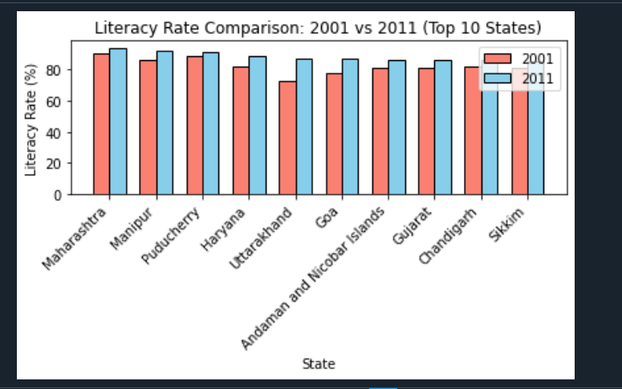

Chart 2: A scatter plot of literacy rate versus poverty rate for 2011, illustrating the general inverse relationship between education levels and poverty.
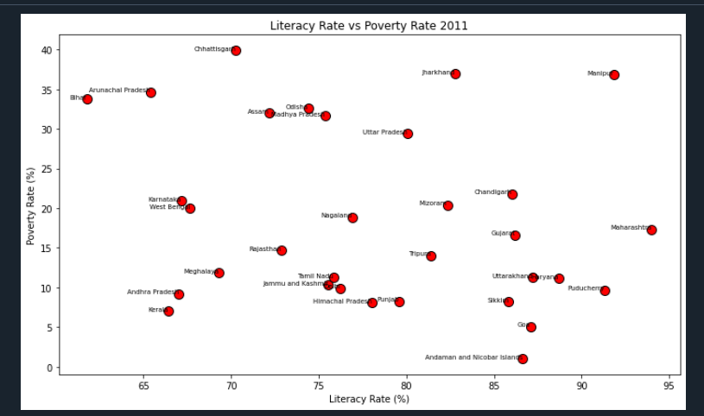

Chart 3: A bar chart ranking all states by income growth between 2001 and 2011, highlighting Goa, Delhi, and Sikkim as the fastest-growing states economically.
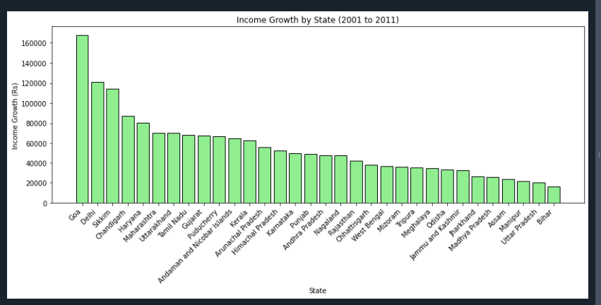

Chart 4: A side-by-side bar chart comparing unemployment rates in 2001 and 2011 across all states, showing that some states such as Nagaland and Tripura saw sharp increases in unemployment, while others such as Rajasthan and Sikkim showed improvement.
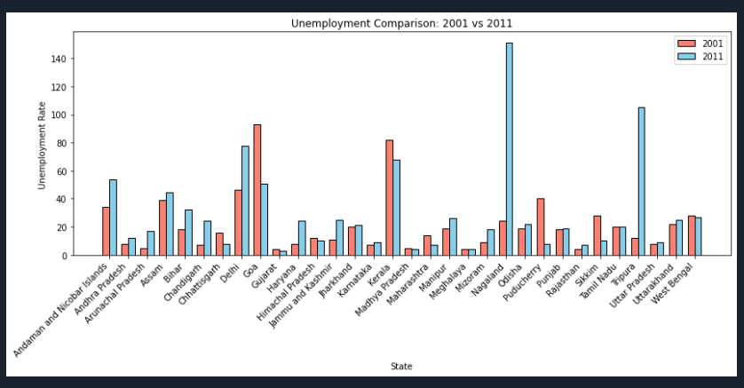

These four visualizations were combined into a single dashboard summarizing the overall findings.

7. CONCLUSION
The analysis shows that India made measurable progress in literacy between 2001 and 2011, with every state showing improvement. However, this progress in education has not translated uniformly into reduced unemployment or poverty. States such as Bihar, Chhattisgarh, Jharkhand, Arunachal Pradesh, and Odisha continue to show a combination of lower literacy, higher poverty, and slower income growth, marking them as priority regions for intervention. States such as Nagaland and Tripura, despite reasonable literacy levels, saw unemployment rise sharply over the decade, indicating a gap between education and employment opportunities.

8. RECOMMENDATIONS FOR NAYEPANKH FOUNDATION
Based on these findings, the following recommendations are suggested:
First, prioritize education programs in states with the lowest literacy and highest poverty, particularly Bihar, Chhattisgarh, Jharkhand, Arunachal Pradesh, and Odisha, where the data shows the greatest combined need.
Second, combine literacy programs with skill-development and vocational training, since states like Goa and the Andaman and Nicobar Islands show that literacy alone does not guarantee employment.
Third, focus additional attention on states with rising unemployment despite reasonable literacy, such as Nagaland and Tripura, where job-creation and employability programs may be more urgent than basic literacy programs.
Fourth, use Gujarat and Maharashtra as reference models, since these states demonstrate that high literacy combined with strong vocational and industrial ecosystems can result in very low unemployment.

9. TOOLS AND TECHNOLOGIES USED
Python, Pandas, Matplotlib, Seaborn, Spyder IDE

----THANK YOU----

